

**Assignment Cover Sheet**

|  |  |
| --- | --- |
| **Subject Code:** | CSIT128 |
| **Subject Name:** | Introduction to Web Technology |
| **Submission Type:** | Report |
| **Assignment Title:** | PlateShare Group-6 Report (Assignment-2, Deliverable-1) |
| **Student Name:** | Reece Bridle, Naveen Bhojan, Taras Mirnyi, Aagna Sapavat, Samyukth Kalathil |
| **Student Number:** | 8448401, 4799586, 8239988, 8444109, 8233718 |
| **Student Phone/Mobile No.** | +971 50 802 4389, +971 50 866 5131, +7 985 980-44-06, +971 58 566 3924, +971 54 594 1501 |
| **Student Emails:** | [ass145@uowmail.edu.au](mailto:ass145@uowmail.edu.au), [ntb123@uowmail.edu.au](mailto:ntb123@uowmail.edu.au) , [tm953@uowmail.edu.au](mailto:tm953@uowmail.edu.au), [spk886@uowmail.edu.au](mailto:spk886@uowmail.edu.au), [Reb493@uowmail.edu.au](mailto:Reb493@uowmail.edu.au). |
| **Lecturer Name:** | Dr. Abdullah ElNokiti |
| **Due Date:** | 23/June/2024 |
| **Date Submitted:** | 23/June/2024 |

|  |  |
| --- | --- |
| **PLAGIARISM:** The penalty for deliberate plagiarism is FAILURE in the subject. Plagiarism is cheating by using the written ideas or submitted work of someone else. UOWD has a strong policy against plagiarism.  The University of Wollongong in Dubai also endorses a policy of non-discriminatory language practice and presentation.  **PLEASE NOTE:**STUDENTS MUST RETAIN A COPY OF ANY WORK SUBMITTED | **DECLARATION:** I/We certify that this is entirely my/our own work, except where I/we have given fully-documented references to the work of others, and that the material contained in this document has not previously been submitted for assessment in any formal course of study. I/we understand the definition and consequences of plagiarism.  **Signature of Student:** |

|  |  |  |  |
| --- | --- | --- | --- |
| |  |  | | --- | --- | | **Optional Marks:** | | | **Comments:** | |

|  |  |  |  |  |  |  |  |  |  |  |  |  |  |
| --- | --- | --- | --- | --- | --- | --- | --- | --- | --- | --- | --- | --- | --- |
| |  |  | | --- | --- | | **Lecturer Assignment Receipt**(To be filled in by student and retained by Lecturer upon return of assignment) | | | **Subject:** | **Assignment Title:** | | | **Student Name:** | **Student Number:** | | | **Due Date:** | **Date Submitted:** | | | **Signature of Student:** | | |



**Table Of Contents**

**Problem Description** 3

**Proposed Solution** 3

**Diagram** 4

Explanation 4

**Home Screen** 4

HTML 5

CSS 5

JavaScript 6

**Recipe View** 6

HTML 6

CSS 6

**Forgot Password Section** 7

HTML 7

CSS 7

**Sign-In and Sign-up** 7

HTML 8

CSS 8

JavaScript 9

**My Posts and Account Settings** 9

HTML 9

CSS 10

**Node.js and MySQL (Backend)** 10

MySQL 10

Users Table 10

Recipes Table 11

Ingredients Table 11

Steps Table 11

Session Management 11

Screenshots 12

Member participation 15

**References** 16

# **Problem Description**

As the online world continues to expand daily, we see more users joining online platforms to share their experiences with people in communities they are passionate about. Whether it's to discuss something theoretical or creative, people of all types and ages have access to these platforms whenever they need them. These are spaces where users may read through the experiences of others or share their own expertise.

Hence, there is a big need for a space where people could share their own recipes or even browse through other people's recipes. A sort of social media for this community, that is organized by new and latest recipes, with user ratings and reviews, and precise information on the steps for each recipe.

A need for not only the user site but also an administration site, so that users may post their own content in a pre-made, easily comprehensible manner and do it all from one location. Software that is this simple to use and navigate is desperately needed to handle all of these problems.

# **Proposed Solution**

Now that we know exactly what could make the users have an enjoyable and productive experience, our proposed solution? **PlateShare.**

PlateShare is a web application that provides its users with a one place solves all solution, that not only tackles a user trying to browse recipes, but also creators who want to share their recipes. Additionally, we value the privacy of our users greatly and require authentication each time a new or returning user attempts to log in. We've also included a few innovative and fresh features to enhance the user experience. For instance, our menu bar is a simplistic action design where the menu expands out to allow the user to interact with it without having to continuously click on a bothersome, stationary bar.

# **Diagram**

# Explanation

## **Home Screen**

The Home Screen is the main page that helps the user connect to all the other options. Here we have used a “hamburger” style menu (3 lines on the top left corner), which acts as a pop-out from where the user can pick any of the options such as home, posts, new post, saved, friends, FAQ and contact options.

Since this is the first page the user sees, this is where the user can pick one of 5 options which are directly presented and can easily be picked by the user. On one click the user can pick whichever cuisine they want from options like Italian, Comfort, Mexican, Quick and Greek.

Following this is a section that includes all the new recipes uploaded by other users, along with their ratings and last uploaded timings, so the user can easily navigate the most preferred recipes and filter through them based on their relativity.

### HTML

“Menu.html” contains the main home screen html code, including the hamburger menu as a div.

* Key elements:
* Hamburger menu has the links to the respectful different pages.
* The “what are you feeling today?” section has 5 options that also are connected to different cuisines which the user can pick.
* The new recipes section has user names, ratings and last modified.

### CSS

“Home.css” is attached as a link to the html file. It includes the following.

* Key Elements
* The Hamburger menu has small icons like emojis that give the user an easily-identifiable menu. It also has a different hover colour to make the user experience easier.
* JavaScript toggleMenu() function is called through the hamburger menu that is called onclick by the user.
* This menu also displays the user profile picture along with emojis and icons.
* Other User recipes
  + These are all aligned with flex and using columns, so a type of table grid, so each recipe is properly aligned and stylized to have a clean look and feel.
  + This keeps the webpage clutter free and increasing usability.
  + Small details like the gold rating stars enhance the overall experience of the user and helps the webpage feel more understandable and simpler to use.
  + Hamburger menu
    - Since the menu bar doesn’t leave when you scroll down, this allows user to access the menu at all times and not get accidentally redirected to another page.
    - This creates a very hard-to-miss, concrete menu that can be used throughout the web application without the user having to constantly lose it.
    - Also, since it is a pop-up menu, user does not have to scroll to heading area again to access it since it stays open when opened once.
    - User also does not have to keep it open, or have it open all the time like the menus usually put at the top of pages. Here, the user has a choice to either use it or keep it out of user view making the page look cleaner and organised.

### JavaScript

“Home.js” is the file in which the toggleMenu() function is accessed in order to make the menu more dynamic.

**To summarise the important and dynamic aspects**, in the JavaScript using a display flex, makes the menu a type of flexbox which aligns the options the user can pick properly hence making user experience better. It makes the page more dynamic and usable based on what the value of the menu.style.display is using an if and else statement for both scenarios.

## **Recipe View**

“Recipe.html” has a link to the external CSS file, it also contains a link to the previous or “back” page along with the recipe that the user is trying to read.

### HTML

* Intro/top section
* First section includes the recipe title, last updated date, rating and extra information. This includes information like time required to prepare dish, cook time, difficulty and the amount of people it serves.
* This allows the user to properly decide if this recipe is suitable for them.
* Ingredients and Instructions
  + This section includes a clear image of the recipe the user is trying to achieve along with a unordered-list consisting of all the ingredients needed.
  + The instructions are in an ordered-list so the user is aware of the exact number of steps needed to finish the recipe.

### CSS

* Key Elements
  + The main stylizing is in the image with the instructions, and also the top section with all the information about the recipe.
  + These sections use margins, justify-content attributes with appropriate properties.
  + The Back arrow is also stylized to match the look and feel of the page.
  + The lists are also stylized to be of type disc and appropriate deep colour to make it stand out.
  + Details like the stars and clock icons add to the overall user experience and usability, giving the page a more interesting and easy-to-navigate feel without cluttering the space.

To summarize the important aspects, the top section with stylized attributes makes the page easy to ready and useful information is giving to the user in a clean, usable format. The use of different types of lists helps the user not feel overwhelmed by the information, and makes the otherwise hard-to-understand text more condensed and understandable by breaking it down into steps.

## **Forgot Password Section**

### HTML

* Head Section of the HTML document contains title for the web page and linked resource, an External CSS file for page styling purposes.
* The body of the HTML document has a form as well as an image linked to an external file (Logo Blue) divided using classes that help with CSS styling purpose.
* Form Section of the HTML document collects user information. For paragraphs, two custom tags have been used which is p1 and p2 and div tag for dividing page into multiple sections for easier CSS styling have been used. Button tag is used with type being submission.
* For link redirection, the href attribute has been used as well.

### CSS

* The common styling kept consistent throughout the web application are the font, which is Arial and colours blue, grey and white being used all over including the links and buttons.
* The body is styled to be aligned to the centre and the text in “container” is also made to me aligned centrally.
* The logo is aligned to the top right, and heading, paragraph and button text is all changed to the colour blue. Input and button boxes have rounded borders with stylized text and proper alignment as well.
* The link is styled to fit the aesthetic by removing the underline and changing text colour to grey.

## **Sign-In and Sign-up**

The goal of this section was designing a user-friendly sign-in experience. To make it easy to use and smooth we have used action buttons and other user-input components in the form.

### HTML

Since each sub-division of the form is properly connected to each other, navigating through it is very simple. The key features are:

* Sign-In Form:
  + User inputs their email and password
  + If user has forgotten the password there is a “Forgot Your Password?” option and also “Reset It Here” that can help them solve this issue.
  + Finally, clicking the submit button successfully logs in the user.
* Sign-Up Form:
  + User inputs username, email, password and a password confirmation just to be sure that the user has inputted the intended password.
  + Finally, similar to sign-in, a submit button.
* Overlay Panels:
  + Both left and right-side panels can be alternated between to pick either the sign-up or sign-in options.
  + This creates a very easy to use interface that conveys the message to the users about the two available options.

### CSS

Along with the common colours and font that remains consistent throughout the web application, the other features are as follows.

* Basic styling:
* Every element ha box-sizing to have consistent border and padding along with its width and height.
* Container is centred vertically and horizontally to create a well-balanced symmetrical look.
* Form Styling:
  + Input boxes are stylized with padding, margins and the unified colour palette used throughout.
  + These boxes also have a clean aesthetic, with rounded corners, background colours and even hover effects.
* Overlay Panels:
  + Items inside these panels use a flexbox alignment and has a seamless transition when clicked on by the user.
  + Transform is used to get the overlay effect, resulting in dynamic and visually interesting but also easy-to-navigate user interface.
* Link Styling:
* The forgot password and reset password links are in different colours to emphasize different uses, the reset password being smaller and grey as compared to the forgot password which is more focused on.

### JavaScript

The overlay panels use JavaScript so when either side is toggled, the active state of it is listened to along with the button presses made by the user.

**To summarize the important and dynamic aspects,** including the password recovery links adds to the easy-to-use aspect while keeping in mind how the user might frequently visit the page. The overlay panels transitions enhance the usability and dynamic interaction the user can have with the page.

## **My Posts and Account Settings**

### HTML

The document titled "Account_settings.html" provides a view of the Account Settings Page using HTML and CSS. It presents a user profile page where users can manage their account preferences. The page includes sections for updating information such as bio, username, email and password. Users also have options to sign out or delete their account. The layout consists of a sidebar for navigation and a main content area with input forms.

* Key Features
* Sidebar with navigation links like Home My posts, new post, Saved, Add Friends, FAQs, Contact us.
* Form sections for editing user bio, username, email and password.
* Action buttons for updating information and managing the account (Sign Out, Delete Account).

The document "Posts.html" showcases users posts in a layout that includes images along with posting date ratings and options to edit each post. It also incorporates a sidebar to the one, on the account settings page for navigation purposes.

* Essential Elements
* A side panel featuring links, for easy navigation
* The main section displays posts with images, dates, ratings and options for editing.

### CSS

* Key Styling
* Sidebar styled with fixed positioning and background colour using the unified colour palette.
* Form input boxes designed with padding, border styles and colour schemes.
* Buttons styled with background colours and hover effects to make the feel of the page cleaner and more polished.
* Posts_styles.css file:
* Ensures consistency by including design elements for the containers and sidebars having a clean cohesive feel that is also easy to navigate.
* Unique styles for post details like dates, ratings and links and similar sizes for all the images

**To summarize the dynamic aspect,** by incorporating a sidebar along with style elements such, as colours, fonts and layouts it enhances the user experience seamlessly.

## **Node.js and MySQL (Backend)**

**PlateShare: Taste the World**

* “PlateShare” is built using Express.js, Node.js framework that handles HTTP requests, middleware, and routing. Express-session and connect-MySQL are being used here for the user authentication steps.
* Bcrypt is used to check (hashing) on the password verification step, and in case of attack on the database acts as a safety net.
* MySQL2 is also used for database communication.
* Multer is used to make sure the file uploads are efficient and accurate without any difficulties.
* Route handling done allows proper consistent communication with the database and creates a type of seamless user authentication experience as well as good content management.

## MySQL

The database has the follows key tables:

### Users Table

* This stores data about users id, name, email, password (hashed string to ensure authentication), users’ photo.

### Recipes Table

This stores data submitted by the users. Key fields are:

* id, prepTime, cookTime, servingSize, difficulty
* All fields explaining the recipe in details, these fields are consistent for every recipe that is entered by any user

### Ingredients Table

This includes the ingredients for each recipe entered by any user. Key fields are:

* recipeId, quantityAmount, quantityType, ingredientDescription.
* All of these allow for a flexible number of recipe entries by n number of users, and also accommodating various culinary needs for any person browsing through.

### Steps Table

Outlines each step while creating the recipe. Key fields are:

* StepDescription, this is a string that basically breaks down the recipe instructions to points to provide clear and easy information to the users.

### Session Management

* This entire table is particularly dedicated to handle session data. It is maintained by connect-MySQL and express-session.
* This table includes session identifiers, an expiration date for the session, allowing secure sessions.

The overall design of the database precents redundancy since every table has a clear purpose. They have foreign keys and proper relationships to maintain data integrity.

**In conclusion**, the database of **PlateShare** is well structured to manage user information, recipes along with ingredients and instruction steps. This design is what allows the applications proper functionality making the usability and user-experience smooth and efficient.

# Screenshots

* Main page

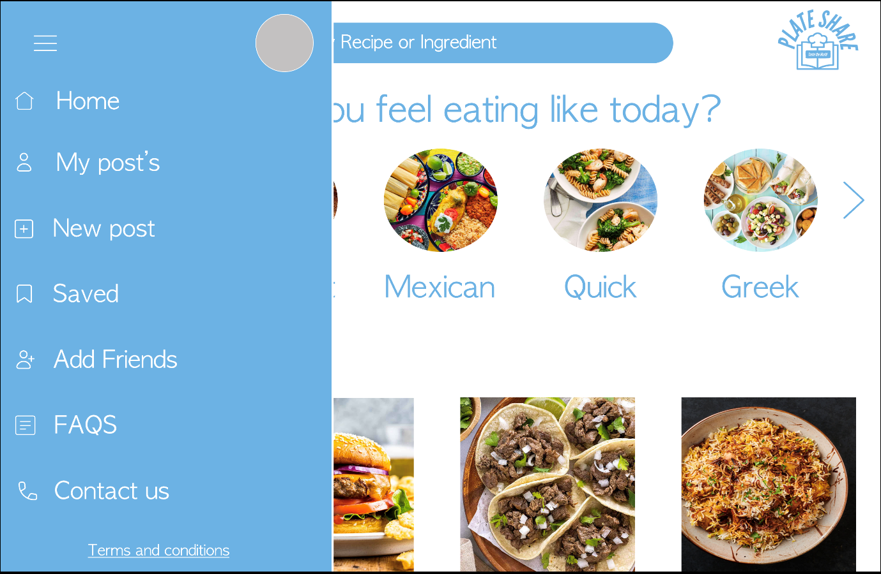

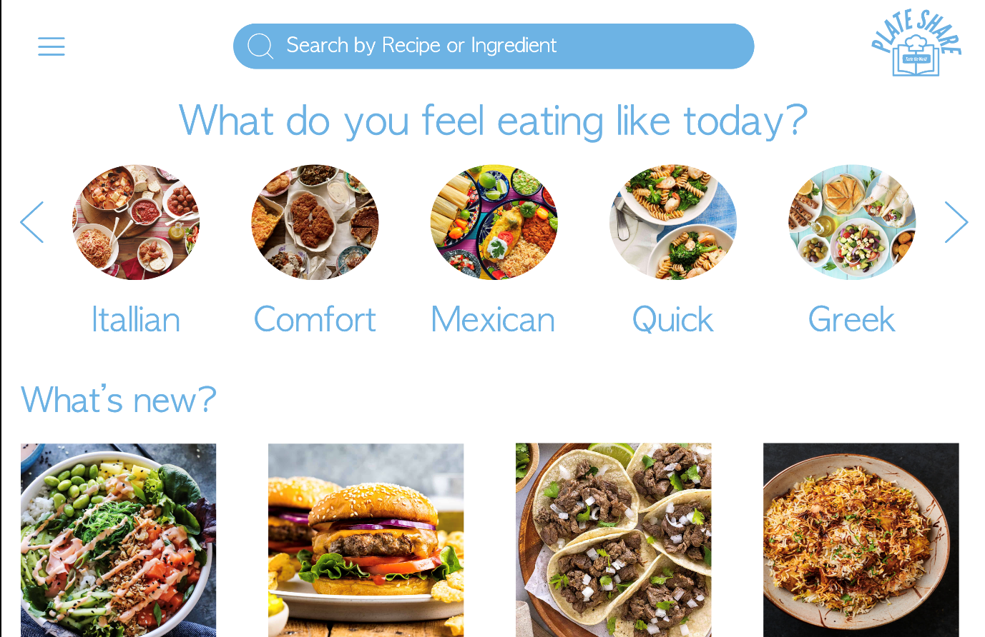

* Dynamically extracted content

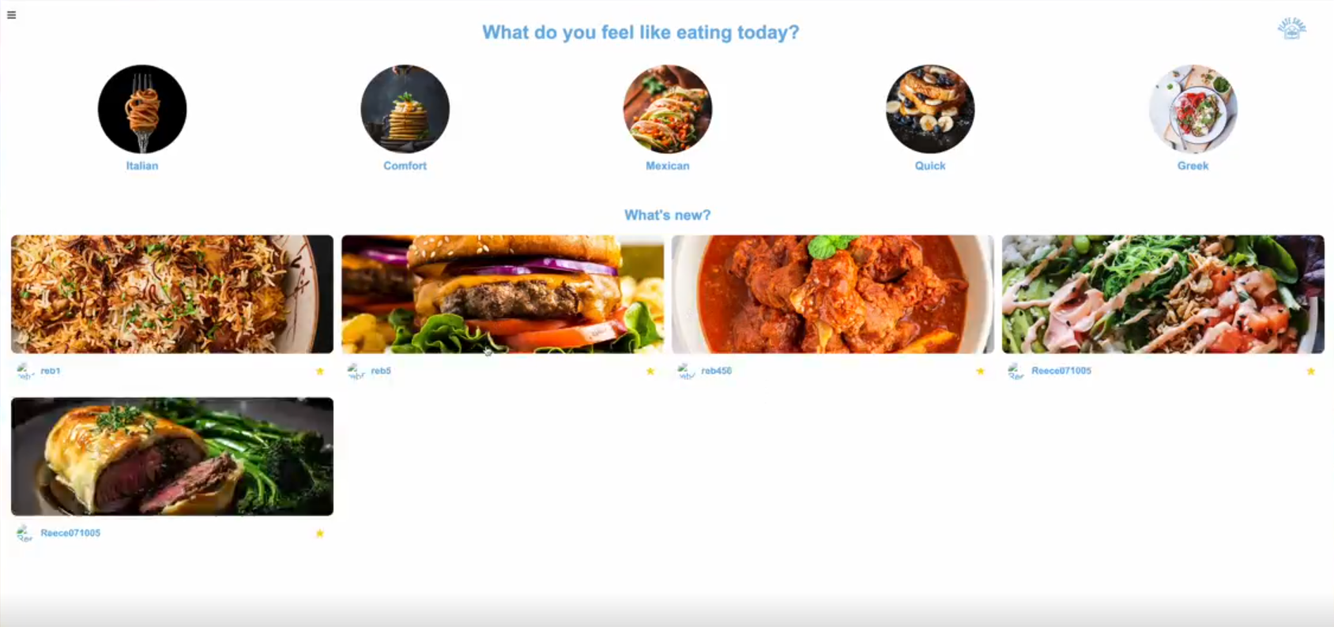

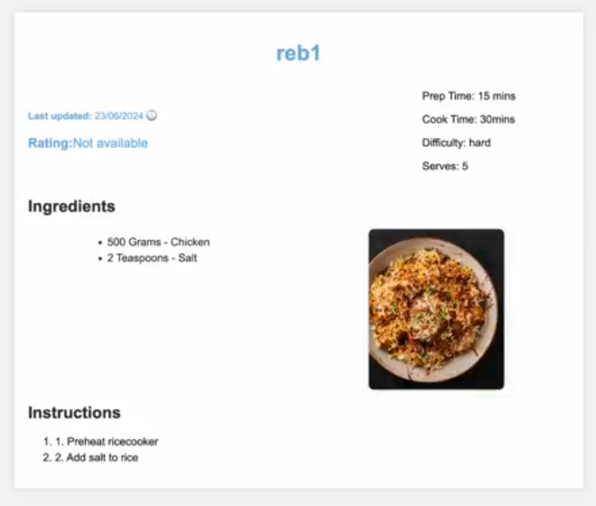

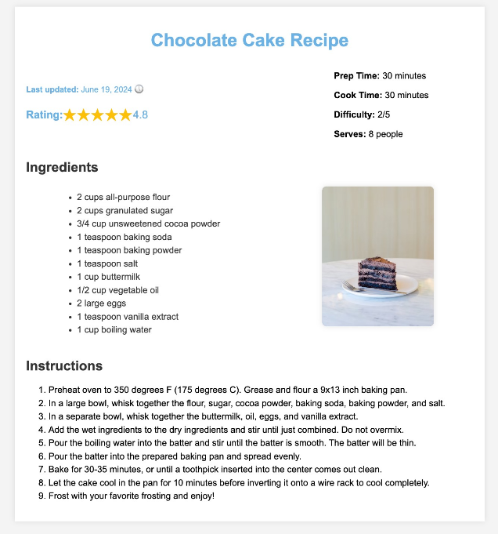

* Forgot Password

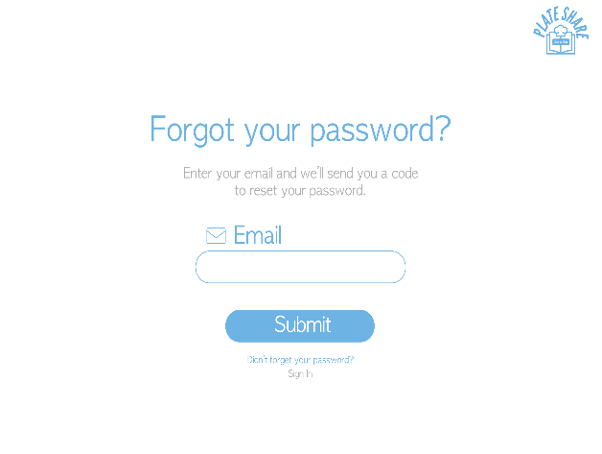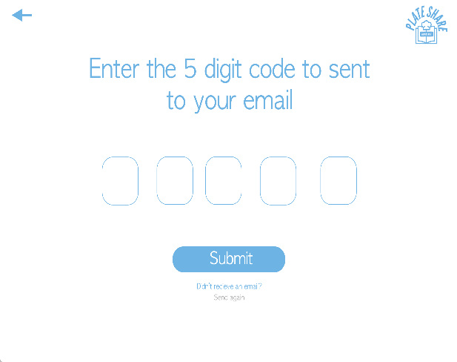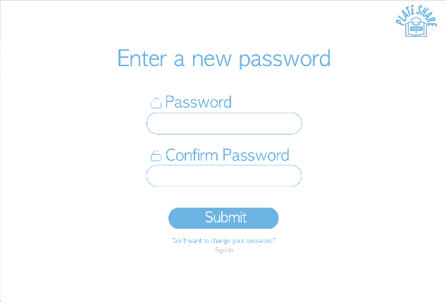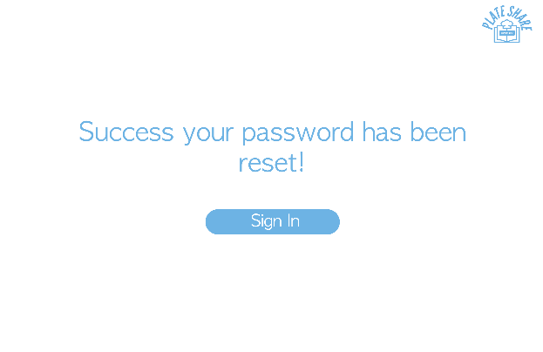

* Post upload

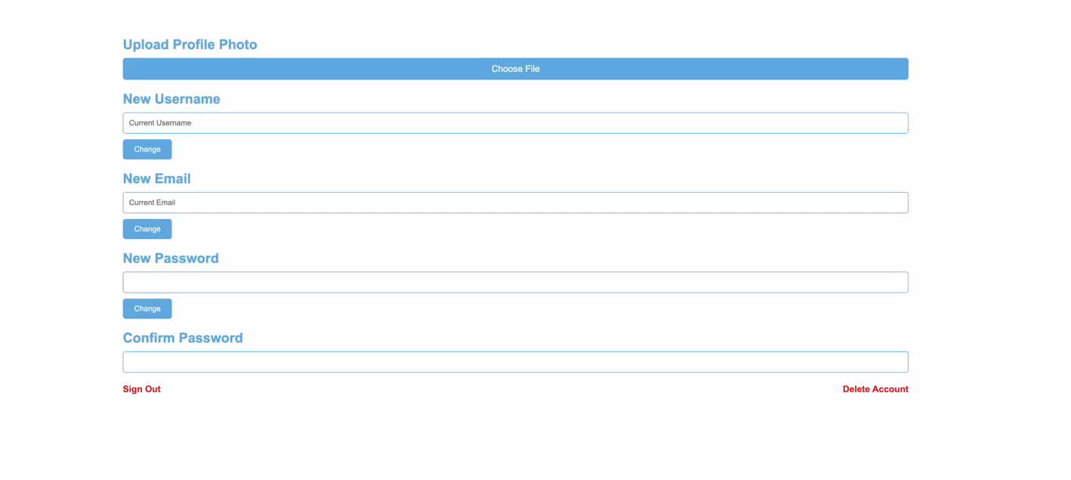

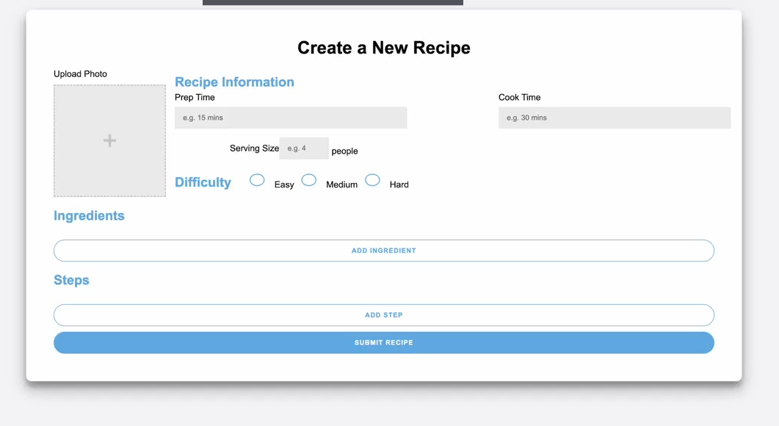

# Member participation

|  |  |
| --- | --- |
| **Name** | **Work** |
| Reece Bridle | Node.js, MySQL and Backend **code**, Design page **layouts, Report** |
| Naveen Bhojan | Forgot password pages **code** and **Report** |
| Taras Mirnyi | My posts and account settings page code, **Report** |
| Aagna Sapavat | Home page and recipe-view pages **code**, **Video**-**Editing**, **Report** |
| Samyukth | Sign-in and sign-up pages **code**, **Report**, **Diagram** |

# **References**

* (w3 Schools, 2024)
* (Geeks for Geeks, n.d.)
* (StackOverflow, n.d.)